**Ch. 16 Notes: *Chemical Composition of Fibers***

🡪Fibers are ____________: long ____________ made of _____________ molecules

**Natural Fibers**

1. 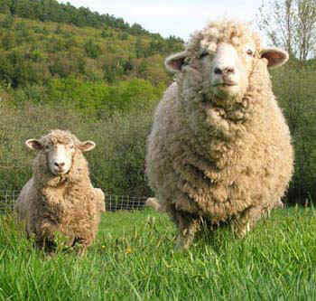W_________
   * + Polymer= ________________________ chains (forming the ____________ keratin)
     + 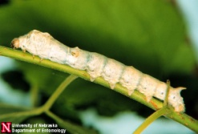Monomer= ____________________________ (one of which is ___________--cysteine contains ___________________)
2. S_________
   * + Polymer= ___________________
     + Monomer= _______________________ (but _____________of a variety than wool)
3. 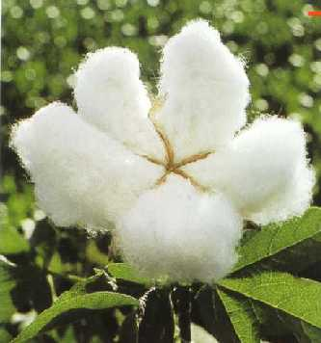C_________
   * + Polymer= ___________________ (plant)
     + Monomer= __________________
4. L_________
   * + Polymer= cellulose (______________ plant)
       - * _______________ chains than cotton which makes it ___________________
     + Monomer= ______________

**Man-made Fibers**

1. Rayon
   * _____________ fiber, then chemically altered, _______________ like ________
2. Acetate
   * Made from a between ______________ and _____________________________

**Synthetic Fibers**

1. Polyamides—linked by _______________ group
   * Example:_____________________
   * _________________ and more chemically __________ than ___________ fibers
2. Polyesters—lined by _______________ group
   * _________________ linkage than polyamides
   * Linkage can be linear (_________________) or cross-linked (_______________)
3. Spandex—structurally similar to _______________
   * 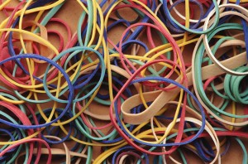Made of segments of _____________________ connected to long segments of polyesters
   * Resulting spandex can stretch up to ________ and recover __________ strength

Images from: http://www.leydenglenlamb.com/photos.htm; http://entomology.unl.edu/images/silkworm/silkworm1.jpg; http://www.texaspolicecentral.com/Texas-Patriotism.php; http://www.flowers-cs.com/flax.html; http://www.imageenvision.com/collection/fitness.html; http://www.fingerpainrelief.com/rubber-band-therapy-for-finger-pain